Posted 07/16/2012 at 8:38 am by JAV

Town Hall Building Committee

DRAFT Agenda
Old Library – fireplace room
Wednesday July 18, 2012
8:45 AM

- Approve minutes

- Approve invoices

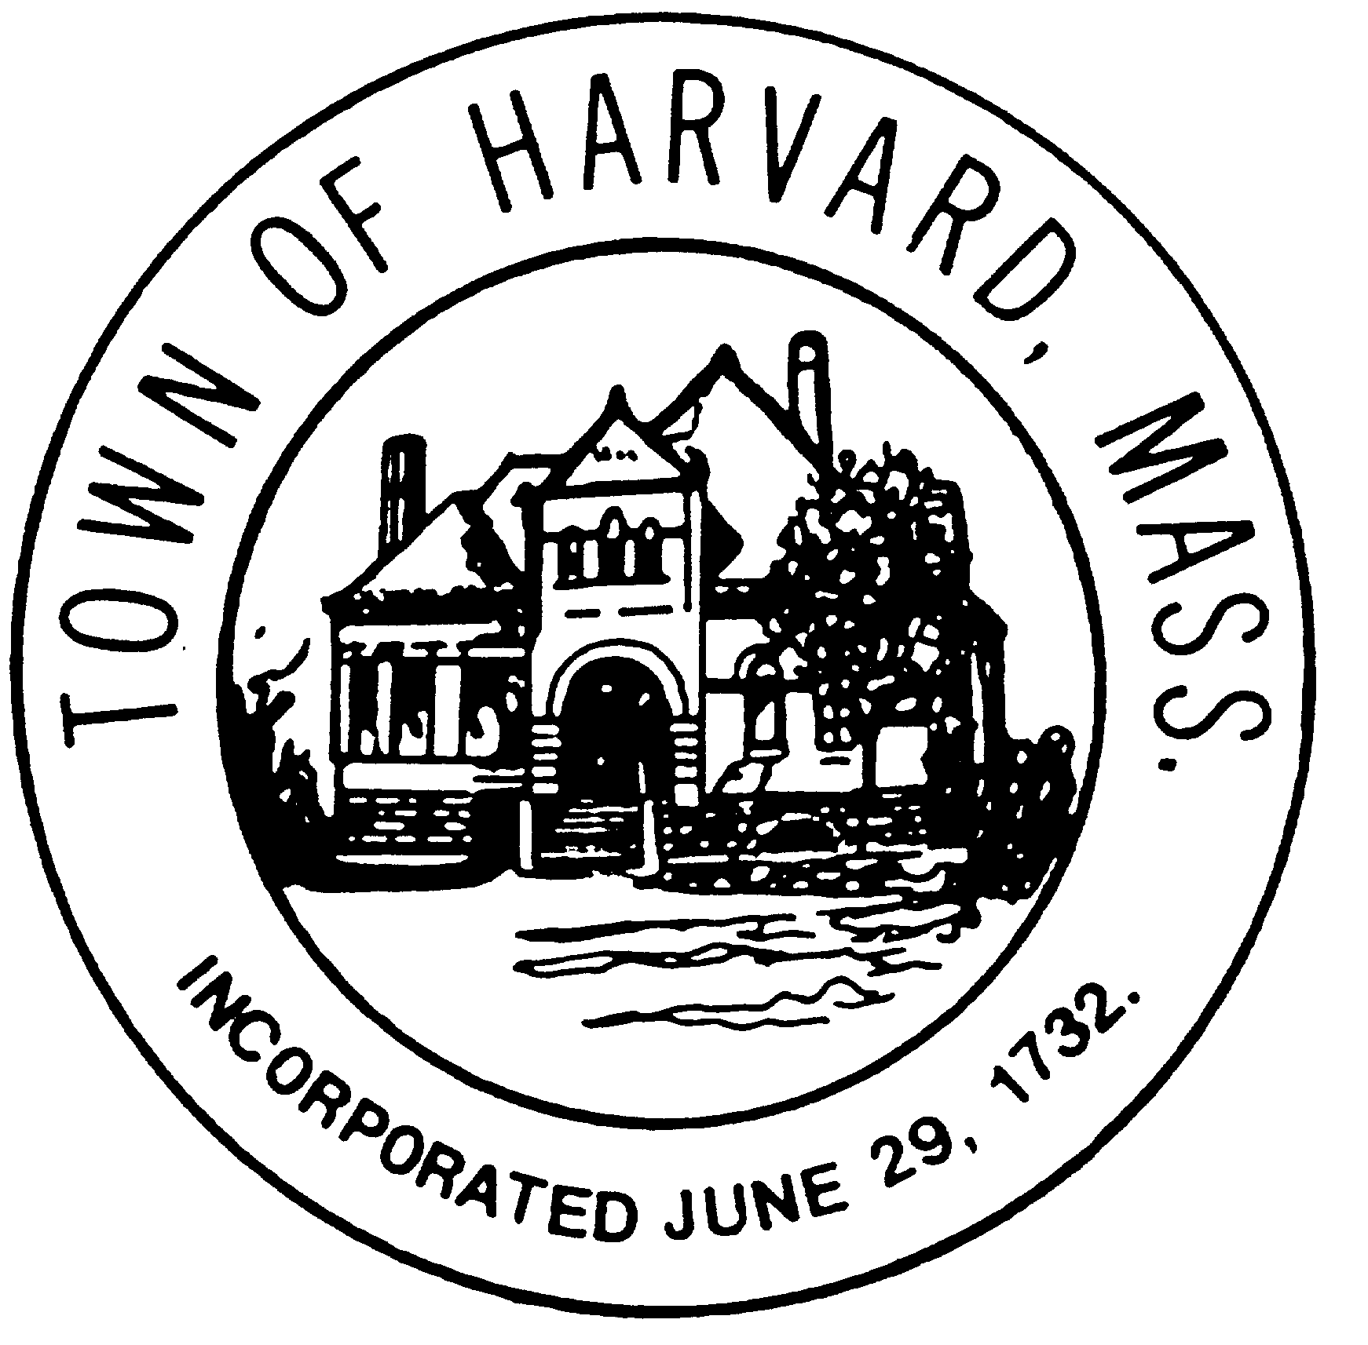
- LLB DSB evaluation

- Discuss draft agreements with LLB and DTI

- Schedule fee negotiations with DTI

- Agenda and date for next meeting(s)

- New business

